Under embargo until the 29th of September 2026

PRESS RELEASE
by the European Network on Independent Living – ENIL

Disabled People March to Demand Funding for Independent Living

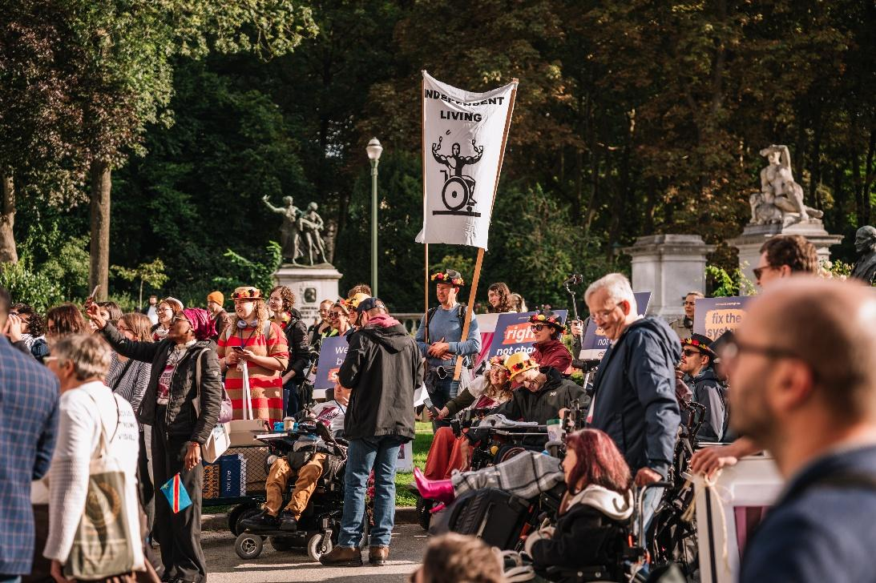

On 1 October 2026 from 09:15, 400 disabled people and allies will march through Brussels (from Parc du Cinquantenaire to the European Parliament) to demand an end to EU funding for institutions and investment in the support needed to live independently. The Freedom Drive demands also address the barriers that prevent disabled people from choosing their homes, pursuing work and making decisions about their own lives.

Accessible, affordable housing is essential to Independent Living. Anna Decandia spent more than a month looking for wheelchair-accessible accommodation when she moved to Brussels for a traineeship. She found only one room, leaving her sharing common spaces with fifteen other people and paying what she describes as excessively high rent.

“The main entrance and the door to my apartment are so heavy that I cannot get in and out without help,” she says. “This hinders my independence as I do not have the freedom to do whatever I want, when I want to.”

For Christos Meletis, finding an accessible home in Brussels also meant paying extra simply to secure it. “I also paid an extra €500 because I rented it earlier than I needed to, just so I would not lose it,” he says. “It should not take this much money, effort and compromise to find a home you can decently live in.”

ENIL demands that EU funding be redirected from institutions to Independent Living services, including personal assistance. Grigoris Chryssikos describes what that support makes possible. Previously, getting out of bed, going to work or meeting friends depended on the availability of family and friends. Paying privately for essential support was financially unsustainable.

“I can decide when to go to work, when to meet friends, when to exercise or even when to go to bed,” he says. Personal assistance has also relieved the financial burden on his family and given him greater freedom to plan his future.

ENIL’s demand for inclusive employment calls for better funding for support in the open labour market. Actor and dancer Damian Bright, from Switzerland, describes how funding decisions can prevent him from accepting work:

“I have been invited to work as an artist many times. However, the logistics around rehearsing and performing would require assistance. This has been denied and I was told work in a workshop will be more economical for the state.”

Damian’s account shows why access to a job alone is not enough: disabled people need assistance to pursue the work they choose.

ENIL also demands full legal capacity and access to supported decision-making. Yannis Vitsos, an ENIL volunteer who is blind, describes being told he needed a sighted person to act as a legal witness when opening a bank account and, on another occasion, when giving a statement to the police.

“I was an adult, I knew what I wanted to do, and I was perfectly capable of making the decision myself,” he says. “But there is a big difference between helping someone access a process and requiring another person to validate their decisions.”

Those issues and more will be highlighted, and brought directly to policy makers, from more than 400 disabled people and allies who are expected at the Freedom Drive, organised by ENIL from 29 September to 1 October under the slogan “NO MORE EXCUSES – OUR TIME IS NOW!”

Grigoris puts the funding demand directly to EU decision-makers: “To be honest, I find it strange that we still have to convince decision makers to choose between funding freedom and funding segregation.”

Journalists are welcome to join the protest and any other part of the Freedom Drive. For more information and details contact Florian Sanden, ENIL Policy Coordinator, florian.sanden@enil.eu, 0032 484 26 25 21

Additional information
This year marks 20 years since the adoption of the UN Convention on the Rights of Persons with Disabilities. At the end of the march, protesters plan to hand their demands to Members of the European Parliament.

Read the complete Freedom Drive 2026 demands.

Protest on 1 October 2026

Gathering: 9:15 at Parc du Cinquantenaire, Avenue de la Joyeuse Entrée 25, Brussels, with speeches and media interviews.

March: 10:30, with arrival at the European Parliament scheduled for 11:45.

The Freedom Drive programme also includes workshops, a hearing at the European Parliament and a conference on housing. See the event programme for details.

About the European Network on Independent Living

The European Network on Independent Living – ENIL is a Europe-wide network led by disabled people, with members throughout Europe. We are fighting for an end to discrimination, for inclusion and equal rights, and for the full self-determination of disabled people.

Sponsors and funders
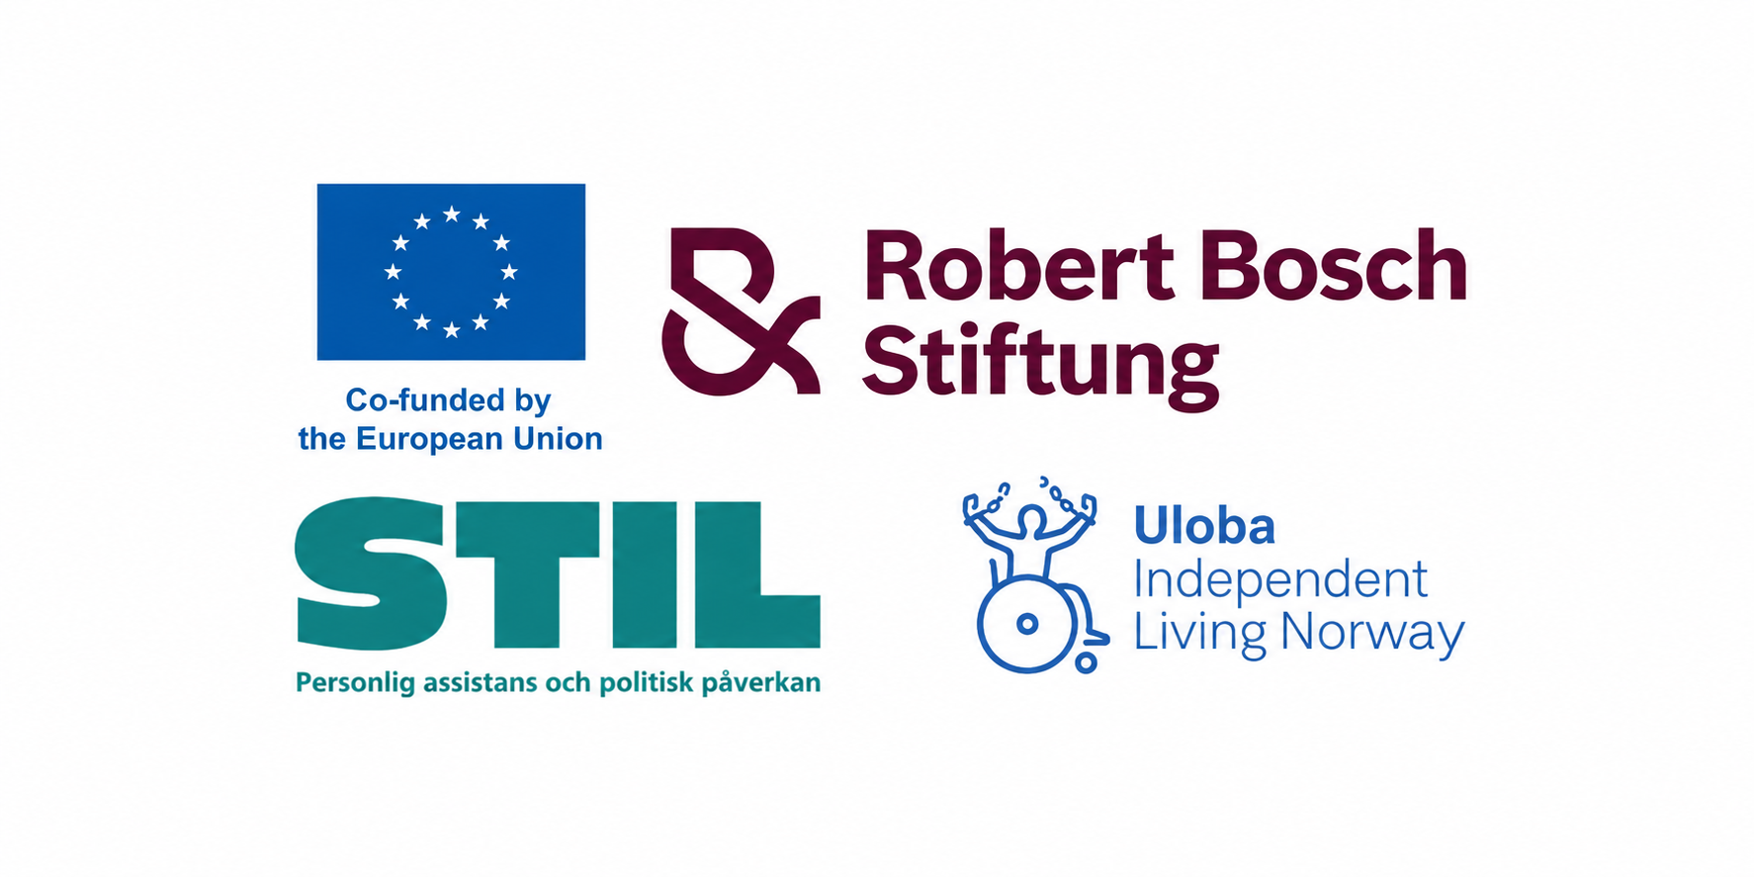
Funded by the European Union. Views and opinions expressed are however those of the author(s) only and do not necessarily reflect those of the European Union or the European Commission. Neither the European Union nor the granting authority can be held responsible for them.

