Freedom Drive 2026 Media Pack
Information for the media
29 September–1 October 2026 | Brussels, Belgium
NO MORE EXCUSES – OUR TIME IS NOW!
From 29 September to 1 October, up to 400 disabled people and allies are expected in Brussels for the 12th Freedom Drive, organised by the European Network on Independent Living (ENIL). Together, they will call on European decision-makers to turn the right to Independent Living into a reality.
The Freedom Drive brings disabled activists together to share experiences, build connections and bring their demands directly to policymakers. This year’s programme includes workshops, a protest march, a hearing in the European Parliament and a conference on housing. The event marks 20 years since the adoption of the UN Convention on the Rights of Persons with Disabilities (UN CRPD).

The changes we are calling for
Disabled people must be able to choose where and with whom they live, work on an equal basis with others and make decisions about their own lives. The five Freedom Drive demands call on the EU, its Member States and other European countries to:
- End EU spending on segregation and invest in support for Independent Living.
- Ensure affordable homes that disabled people can access, and tackle housing discrimination.
- Open the mainstream labour market to disabled people through inclusive employment.
- Uphold disabled people’s authority over their own decisions, with support when they choose it.
- Deliver equality for disabled women and girls, including bodily autonomy and accessible protection from violence.
Read the full Freedom Drive 2026 demands

About ENIL
The European Network on Independent Living is a Europe-wide, user-led network of disabled people. ENIL advocates for human rights and inclusion through self-determination, peer support and solidarity. Its work promotes accessible environments, personal assistance and the support disabled people need to exercise choice and control over their lives. The Freedom Drive has been one of ENIL’s key campaigns since 2003.

Meet the Freedom Drivers
Journalists are invited to hear directly from disabled people about the barriers they face and the changes they are calling for. The published programme includes media interviews before the protest march.

The protest and media interviews
The protest march will take place on Thursday 1 October 2026. Participants will gather at the entrance to Parc du Cinquantenaire at Avenue de la Joyeuse Entrée 25, Brussels. Speeches and media interviews are scheduled from 09:15, with the march beginning at 10:30 and reaching the European Parliament at around 11:45. Participants plan to present their demands to Members of the European Parliament.
The programme also includes a European Parliament hearing on EU funding and a conference on housing and Independent Living. Advance registration is required for the hearing. All times are local to Brussels; the programme is subject to change.
For media enquiries and interview arrangements: florian.sanden@enil.eu
Freedom Drive website
Latest programme and venues

Testimonials - What our participants are fighting for

Why we are coming together
“I want to participate in the 2026 Freedom Drive because the Freedom Drive brings me hope and joy. The previous Freedom Drive in 2024 was a mind-changing experience for me. I heard messages from disabled activists and connected with many disabled people who shared similar life experiences. I realised that my experience as a disabled person is not unique and that there is already a group of people with similar struggles fighting for a better future. I hope the Freedom Drive will lead to a stronger disabled people’s movement and show us the power we can have together!”
(Sofia Paiva Goncalves, Belgium)
“I am motivated by solidarity. More than ever, I believe disabled people and the Independent Living movement need to stand together across countries and cultures. I am coming to the Freedom Drive to listen, learn, connect, and stand in solidarity with disabled people in Europe as they define the changes they want for their own communities.”
(Kirt Toombs, United States)
“I believe that disabled people should be louder and prouder, especially since our exclusion so often silences our voices. The lack of accessibility, personal assistance and other support services makes it essentially impossible for many of us to protest. For me, one of the goals of the Freedom Drive is to show the political power of the disability community. We need to show that we cannot be ignored and fight for our right to live independently.”
(Christos Meletis, Greece)

Accessible and affordable housing
“When I moved to Brussels for a traineeship, I spent more than a month looking for wheelchair-accessible accommodation and could find only one room. Having only one option meant that I had no choice about where, how and with whom to live. Now I find myself in a co-living situation where I have to share the common spaces with fifteen other people and pay an excessively high rent.
The worst aspect is that, even though it is supposed to be an accessible building, the main entrance and the door to my apartment are so heavy that I cannot get in and out without help. This hinders my independence, as I do not have the freedom to do whatever I want, when I want to. When disabled people are looking for housing, they still have to compromise and decide which needs have priority over the others. And this is unacceptable.”
(Anna Decandia, Italy)
“While trying to find a home in Brussels as a wheelchair user, I got a good idea of the discrimination disabled people face in the housing market. The vast majority of apartments were inaccessible, and in many cases, it was impossible to search specifically for accessible options. When I did find an accessible apartment, it was often too expensive or in an area I did not want to live in.
On top of all that, I had to deal with discrimination from landlords who treated me like I would be too much hassle to rent to. In the end, I had to pay a huge amount to rent an accessible apartment. I also paid an extra €500 because I rented it earlier than I needed to, just so I would not lose it.
It should not take this much money, effort and compromise to find a home you can actually live in.”
(Christos Meletis, Greece)
“The shortage of wheelchair-accessible and affordable housing repeatedly narrows the places where I can live or stay. A home is not accessible merely because I can enter the building: I need enough space to move safely, an accessible bathroom, reliable step-free access, room for assistance and infrastructure that lets me participate in the surrounding community. When only a tiny number of places meet these requirements, choice disappears and dependence increases. Accessible housing must become the ordinary standard, not a scarce special product.”

(Christian Bayerlein, Germany)
“Even though I have a place where I could try to live on my own, the lack of accessibility and the general lack of safety make it impossible, even if living there could give me a chance to live in a bigger city.”
(Olga Białokozowicz)

Funding choice and control
“Public investment should support accessible housing, personal assistance, peer support, transportation, community-based services, and other supports that make genuine choice and control possible. Independent Living is ultimately about freedom: the freedom to choose where and with whom we live, direct our own supports, and participate as equal members of our communities.”
(Kirt Toombs, United States)
“Before having a personal assistant, I depended on my family and friends for almost everything in my daily life. As a result, I depended heavily on my parents, who are getting older, and my life had to fit around other people’s schedules rather than my own.
Personal assistance has given me something much bigger than support. It has given me independence. For the first time, I can organise my day according to my own needs instead of adapting my routines to my parents’ schedules. I can decide when to go to work, when to meet friends, when to exercise or even when to go to bed. Most importantly, it has allowed me to plan my future with much greater freedom and confidence.
Personal assistance allows disabled people to live in the community, make their own choices, work, study and participate in society.”
(Gregoris Chryssikos, Greece)

Inclusive employment
“I experienced two main barriers when I was looking for jobs in the open labour market: physical barriers and attitudinal barriers. For many companies, it is common practice to conduct job interviews on site. Travelling independently to an unfamiliar place would be particularly challenging for me as a visually impaired person.
I considered asking for my job interviews to be held online. However, I feared that this request could lead potential employers to judge me as less capable. So I did not ask and relied on my parents’ support instead. For workplaces to become truly inclusive, employers’ perceptions about disabled people’s capacity to work need to change. Workers and job-seekers need to feel safe to ask for reasonable accommodations.”
(Sofia Paiva Goncalves, Belgium)
“I have about 30% vision, and I used to lack confidence because of my visual impairment. I had to sit very close to my computer or laptop to see properly. Back then, it stopped me from trying for certain opportunities or stepping into professional environments because somehow I didn’t feel professional enough
I wasn’t really used to identifying myself as a disabled person or talking openly about my disability. This was also connected to not having accessible resources and not receiving enough support around disability awareness and self-awareness during my education. I think I developed some internalised ableism myself. I wasn’t confident enough to raise my voice, not only because I was afraid of discrimination, but also because I had internalised some of those attitudes.”
(Fatma)
“I have been invited to work as an artist many times. However, the logistics around rehearsing and performing would require assistance. This has been denied, and I was told work in a workshop would be more economical for the state. I have other employers who provide me with the assistance I need in the field of workshops or work at events. I am very happy such private initiatives exist.”
(Damian Bright, Switzerland)

Making our own decisions
“There have been a few moments where I felt that my legal capacity was being questioned simply because I am blind. I remember being told that I needed a sighted person to act as a legal witness when I wanted to open a bank account, and on another occasion when I went to give a statement to the police. What struck me was how normal these things were considered. I was an adult, I knew what I wanted to do, and I was perfectly capable of making the decision myself. Yet somehow, my blindness meant that another person had to be involved.
Of course, blind people may need accessibility or reasonable support to navigate certain procedures. But there is a big difference between helping someone access a process and requiring another person to validate their decisions.”
(Yannis Vitsos, Greece)
“There have been situations where people or systems have made assumptions about what is best for me because of my disability, rather than asking what I want or providing the support I need to make an informed decision. Sometimes decisions are made with good intentions, but excluding the person concerned can still undermine their autonomy and dignity.”
(Kamran Rafique, Pakistan)

Taking the movement forward
“Freedom Drive is a unique experience and an opportunity to get out of my bubble, make new connections, but above all, gain a fresh perspective on my activism and try to answer the question of who I want to be as an activist. As a Youth Board member, it is also a great opportunity to slowly build my confidence as a facilitator.”
(Olga Białokozowicz)
“I am joining Freedom Drive because I thoroughly believe that real change comes only when we join our forces, ideas and experiences.”
(Yannis Vitsos, Greece)

Journalists are welcome to join the protest and any part of the Freedom Drive. For more information and details contact Florian Sanden, ENIL Policy Coordinator, florian.sanden@enil.eu, 0032 484 26 25 21

Additional information
Protest on 1 October 2026

Gathering: 9:15 at Parc du Cinquantenaire, Avenue de la Joyeuse Entrée 25, Brussels, with speeches and media interviews.

March: 10:30, with arrival at the European Parliament scheduled for 11:30.
The Freedom Drive programme also includes workshops, a hearing at the European Parliament and a conference on housing. See the event programme for details.

About the European Network on Independent Living

The European Network on Independent Living – ENIL is a Europe-wide network led by disabled people, with members throughout Europe. We are fighting for an end to discrimination, for inclusion and equal rights, and for the full self-determination of disabled people.

Sponsors and funders
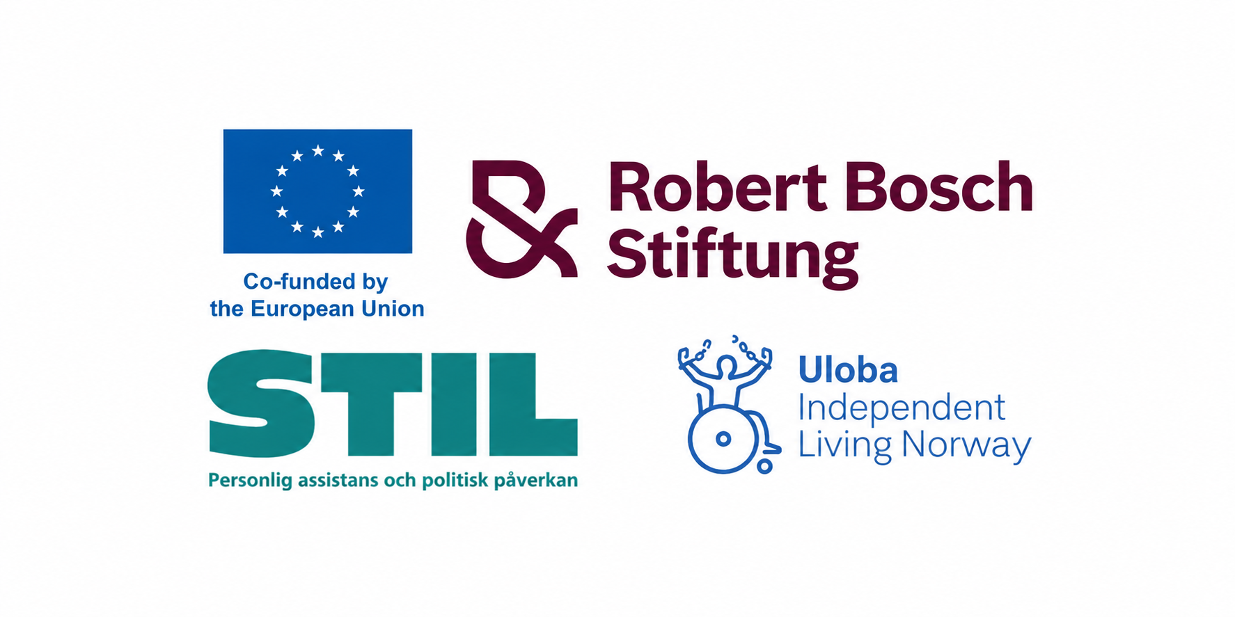
Funded by the European Union. Views and opinions expressed are however those of the author(s) only and do not necessarily reflect those of the European Union or the European Commission. Neither the European Union nor the granting authority can be held responsible for them.

